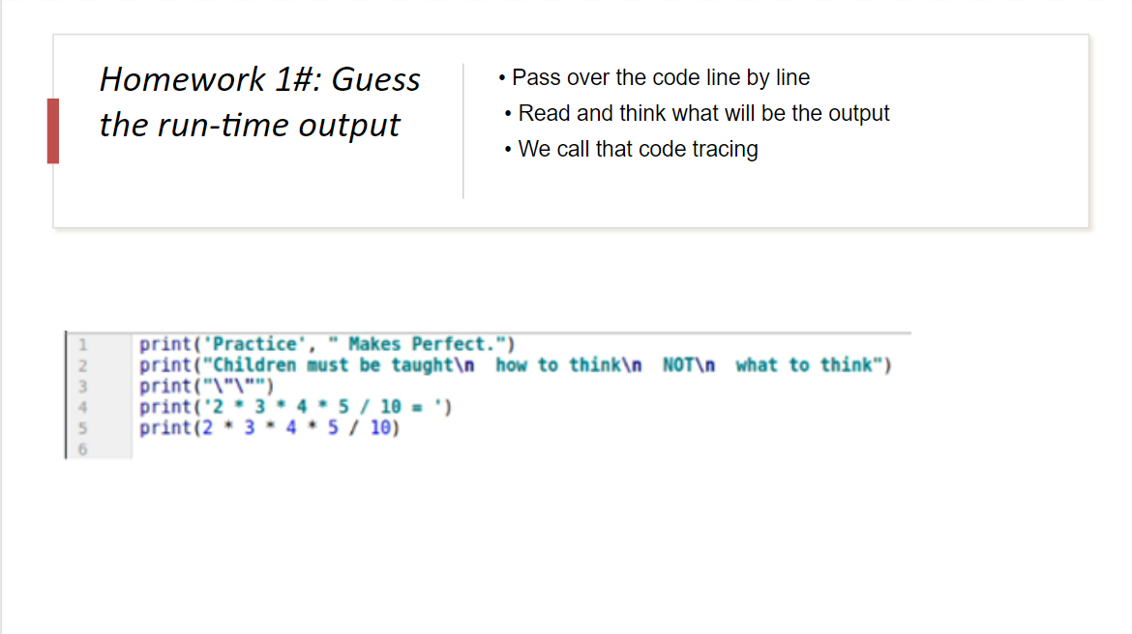Output : Practice Makes Perfect.

Children must be taught

How to think

NOT   
 what to think

“”

2 \* 3 \* 4 \* 5 / 10 =

12